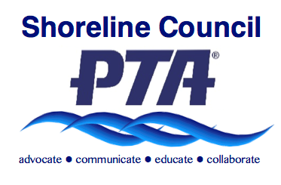

Your Membership in PTA Makes a Difference!
With more than 133,000 members, Washington State PTA (WSPTA) is the largest volunteer association dedicated to the education, health, welfare, and safety of all children in Washington State. When you join PTA, you support local, state and national efforts to improve the lives of children and their families.
A WSPTA membership card is valuable!

Benefits include local and statewide discounts, advocacy, scholarships, programs, volunteer support, services to local PTAs and councils, and training for PTA leaders.

Your membership card also gives you the right to voice and vote at local PTA meetings, and you can help determine the issues that WSPTA will lobby for in the state legislature.

By becoming a PTA member, you ensure that:
- WSPTA continues to be a voice for children & families on more than 30 state commissions & committees.
- Your local PTA leaders are provided with numerous leadership & non-profit management training opportunities, including technical support & resources.
- Most importantly, you ensure that your PTA can continue to provide the programs & services your students, families & teachers need!

All of this at a low cost to you! Each local PTA membership includes:
- National PTA dues: $2.25 per member
- Washington State PTA dues: $5.75 per member
- Shoreline PTA Council dues: $1.50 per member

With a long and rich history of doing the right thing for children and families, today’s PTA is still the premier child advocacy association. Won’t you join us?

